**Bandung School**

The Bandung School generally refers to one of the main streams of modern art in post-revolutionary Indonesia. It is associated primarily with the art school in what is today the Institute of Technology Bandung (ITB), and encompasses the works of the first generations of its students, many of who later became its first Indonesian instructors. Forerunners of the school include Mochtar Apin (1923-1994), But Mochtar (1930-1986), Ahmad Sadali (1924-1987), Sudjoko Danoesoebroto (1928-2006), Syafe’i Soemardja, Srihadi Sudarsono (b. 1931), Popo Iskandar (1927-2000), and A.D. Pirous (b. 1933), all of whom attended the art school during the 1950s. As lecturers, professors and exhibiting artists, they came to define a Modernist and Universalist approach to art practice and a style. This ultimately clashed with nationalist critics during the 1950s who contended that their work lacked an Indonesian soul and did not reflect Indonesianexperience. During the early 1960s, the Bandung School was increasingly under pressure and marginalised by its ideological opponents, most notably from the Communist Party. However, with the sweeping political changes of 1965-1967, the Bandung School artists and their aesthetic philosophy came to prominence in the emerging New Order.

Bandung’s art school began as a Drawing Teachers Training College in the College of Applied Sciences (Technische Hogeschol) in 1947. By that time, the city of Bandung was a Westernised centre of science and technology research, and applied sciences. The school’s art classes were initiated by Dutch painters Ries Mulder (1909-1973) and Simon Admiraal (1903-1993), who developed aspecifically Indonesian arts pedagogy. Based on Dutch arts education, the curriculum emphasised the mechanics of composition, art theory and history, and criticism. Over time, particularly after Dutch recognition of Indonesia’s independence (late 1949), and under the leadership of Soemardja, the training course developed into a comprehensive art school. By the mid-1970s, it included painting, sculpture, ceramics, graphic arts, as well as architecture and interior design courses within what is now the Faculty of Fine Arts and Design at the Institute of Technology Bandung.

Instead of continuing with a pre-war emphasis on strong narrative compositions and landscape painting, the first generation of Bandung artists introduced new styles of painting, most notably a kind of formalism and geometric abstraction. In this regard, their work of the 1950s demonstrates the direct influence of their painting instructor, Ries Mulder, whose own work was heavily influenced by that of French painter, Jacques Villon (1875-1963, older brother of Marcel Duchamp). By the late 1950s, many of the first generation of Bandung artists had left behind this geometric Cubist abstraction in favour of an abstract expressionism that can be seen as a second hallmark style of the Bandung School.

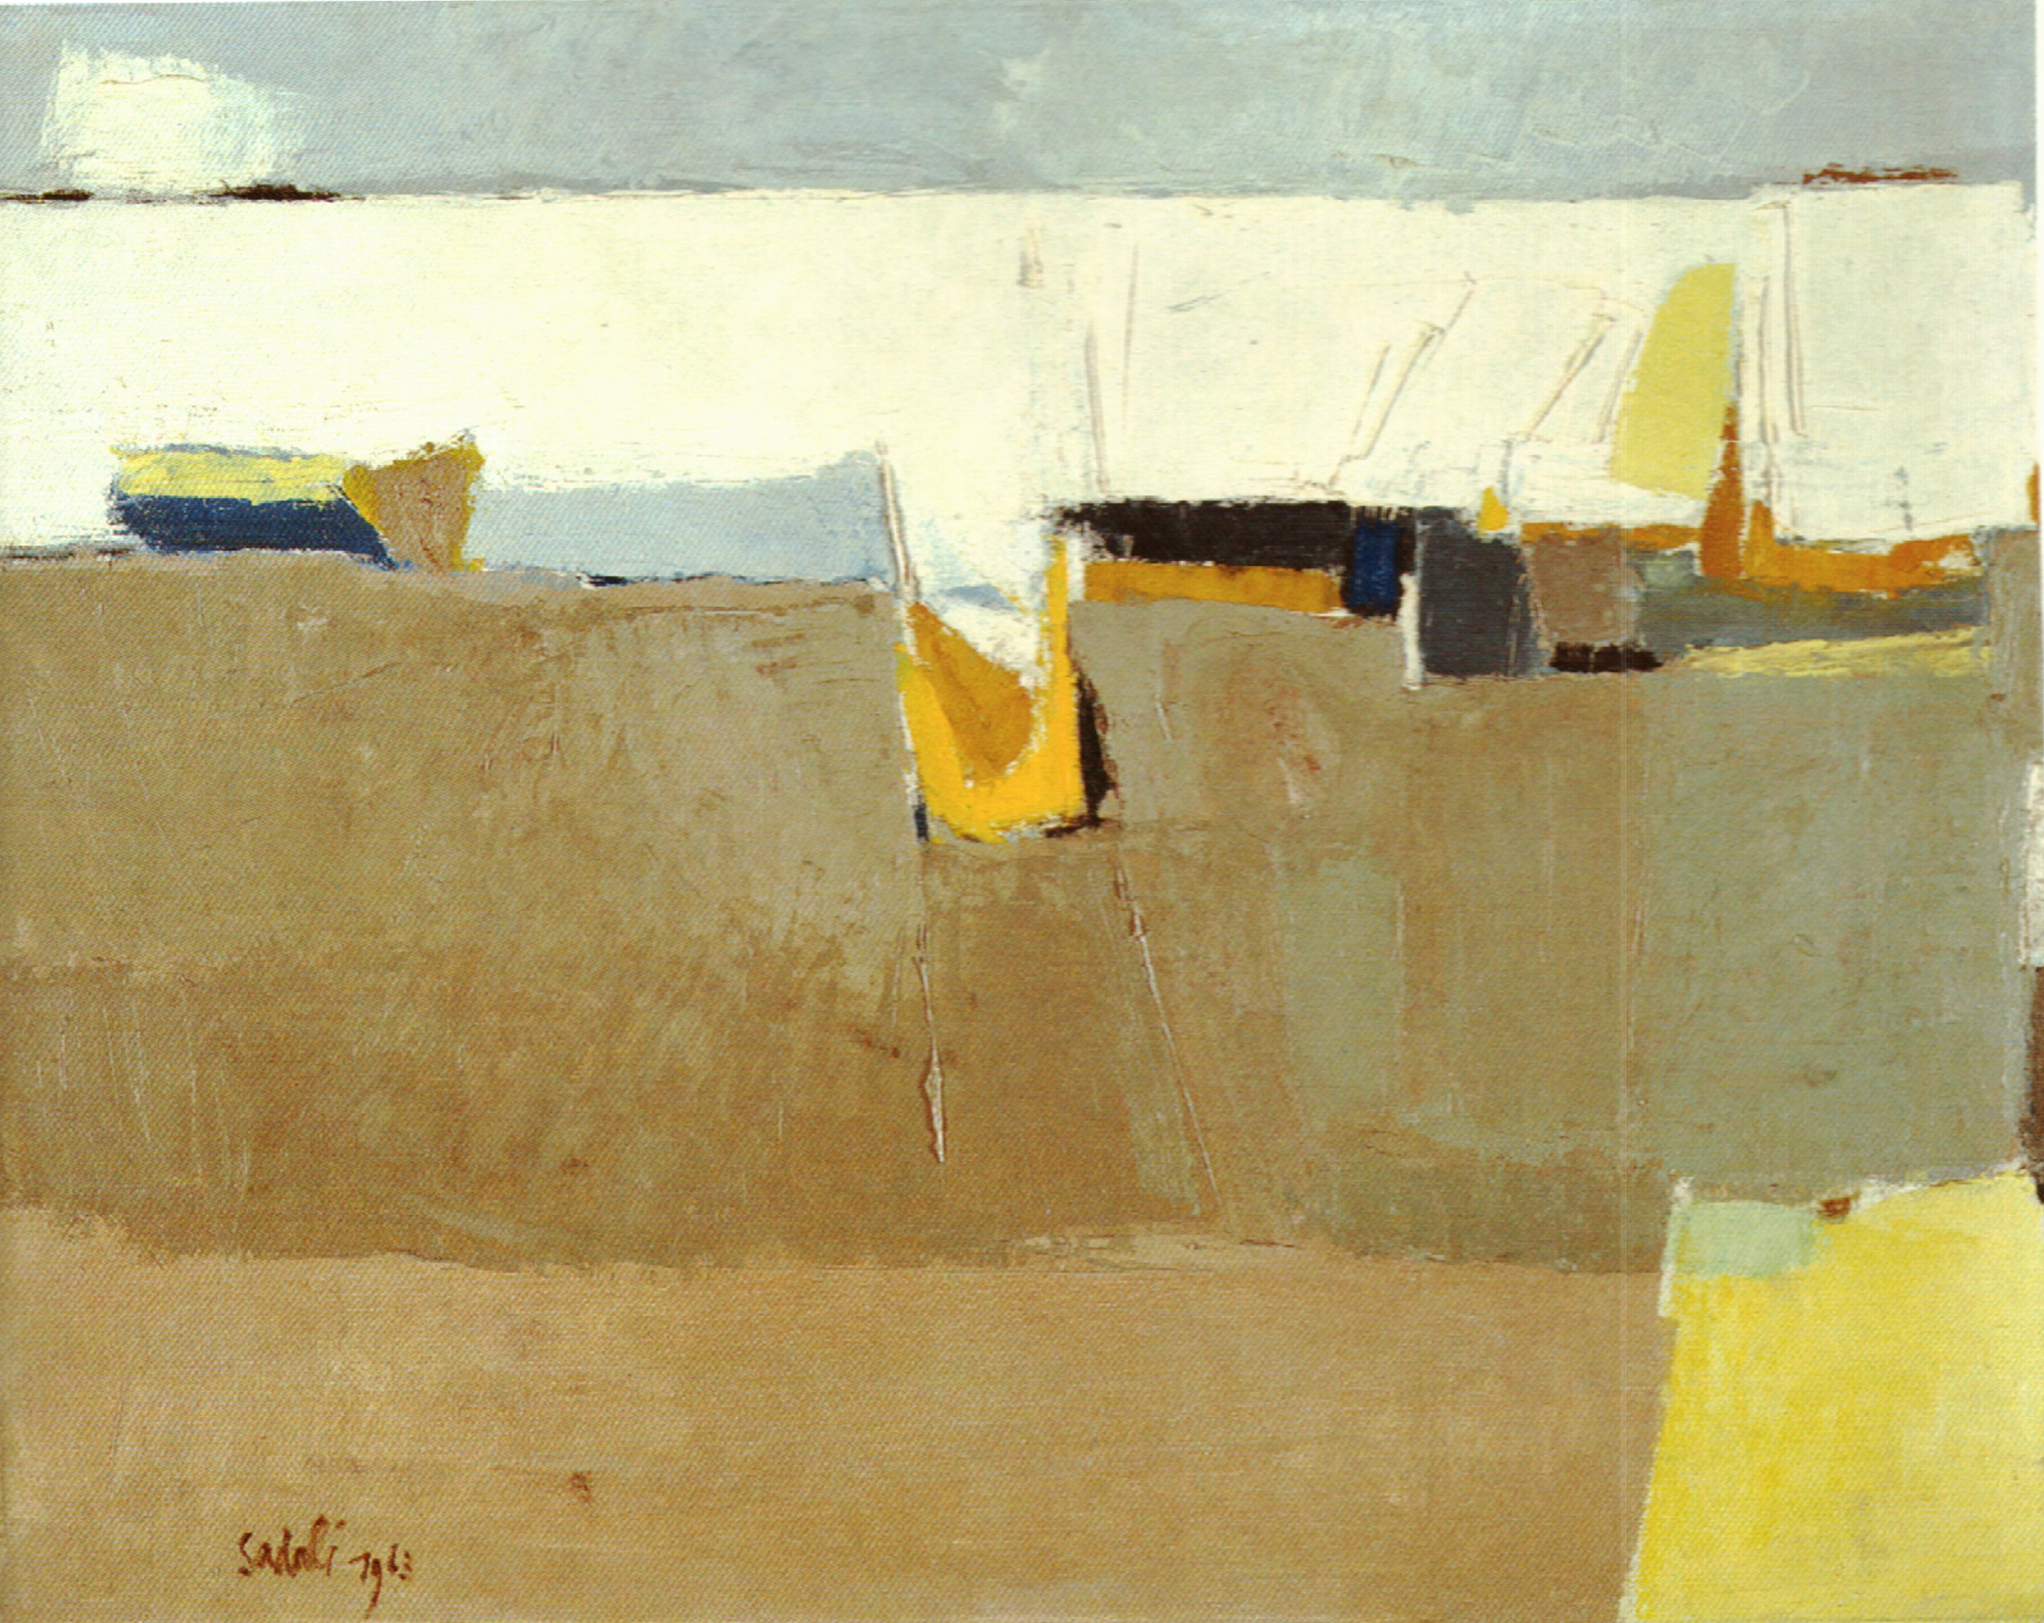

Ahmad Sadali, *Boats at a Wharf*, 1963, 50x65cm, oil on canvas, collection of Dr. Oei Hong Djien. Used with permission of the owner.

This style and ideological orientation of the Bandung school was also partly the product of the Cold War, especially American intervention via scholarships and travel grants. Institutions like the Rockefeller Foundation provided scholarships to thousands of Indonesians, including many artists from the Bandung School, to further their studies abroad. Recipients of such grants and scholarships include Ahmad Sadali, Srihadi Sudarsono, Sudjoko, But Mochtar, and A.D. Pirous.

Ahmad Sadali’s *Boats at Warf* represents this second phase in the Bandung School as the artists began to distance themselves from the initial influence of their instructor and mentor, Ries Mulder. This piece is one of Sadali's works of the early 1960s and after his studies in the United States. At the time of this painting, Sadali was already an influential instructor at the academy at ITB.

A third development in the Bandung School and its approach to art-making began in the early 1970s, in which the school’s artists ventured into a rediscovery of the local, via a predominantly appropriative understanding of Indonesia’s ethnic diversity. Another and more sustainable discourse emerging during this time of the Bandung School was that of a contemporary Islamic Art in Indonesia, which also introduced new combinations of Islamic calligraphic tradition and abstraction. Artists at the forefront of this development, including Ahmad Sadali, A.D. Pirous and Umi Dachlan (b. 1942), among others, were instrumental in forging a discourse of modern Islamic art in Indonesia.

**References and Further Reading**

Claire Holt Papers 1930-1969. Kroch Asia Archives, Cornell University, Ithaca, NY.

Holt, Claire. "The Great Debate." *Art in Indonesia: Continuities and Change*. Ithaca: Cornell University Press, 1967: 211-52.

Spanjaard, Helena. "Bandung the Laboratory of the West." *Modern Indonesian Art: Three Generations of Tradition and Change*. Ed. Fischer, Joseph. Jakarta and New York: Panitia Pameran KIAS/ Festival Indonesia, 1990: 54-77.

Sitor Siturmorang. “Modernisme [Modernism].” *Mingguan Siasat* 392 (12 Dec. 1954): 27.

Sumardjo, Trisno. "Bandung Mengabdi Laboratorium Barat [Bandung Serves the Laboratory of the West]." *Mingguan Siasat* 391 (05 Dec. 1954): 26-27.

Sudarmadji. *Dari Saleh Sampai Aming: Seni Lukis Indonesian Baru Dalam Sejarah Dan Apresiasi [From Saleh to Aming: New Indonesian Art in History and Appreciation]*. Yogjakarta: ASRI, 1974.

Wright, Astri. *Soul, Spirit, and Mountain: Preoccupations of Contemporary Indonesian Painters*. Kuala Lumpur; New York: Oxford University Press, 1994.

Siregar, Aminuddin T. H. et al. *Instalasi Sunaryo, 1998-2003: Saksi Tragedi Kemanusiaan [Sunaryo's Installations, 1998-2000: A Witness to the Tragedy of Humanity]*. Jakarta and Bandung: Kepustakaan Populer Gramedia (KPG); Yayasan Selasar Sunaryo, 2007.